**Women Legal Leaders:**

**Fostering Activism and Solidarity Among Women from Disenfranchised Groups**

A Project of Itach-Maaki Women Lawyers for Social Justice

In cooperation with Haifa University’s Faculty of Law

**Women Legal Leaders**, a joint project of Itach-Maaki and Haifa University’s Faculty of Law, fosters the abilities of Israeli women from Arab and Jewish marginalized communities, together with law students, to become social change activists on issues close to their hearts. The project provides a forum for women from diverse backgrounds to meet, learn about one another, find commonalities and unity, and to create an impact on their shared society.

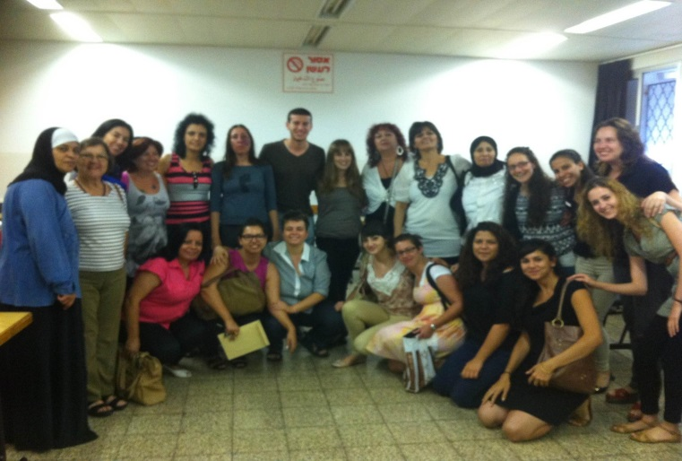In Israel, the voices of women are disproportionately absent from the public discourse. This is particularly true for women from marginalized groups, who are often not heard even within their own communities. As these women – single mothers, immigrants, Arab women, low-income women and others - struggle to meet their basic needs, many important issues they face are not addressed or even discussed in public or in circles of influence --including issues related to their rights to healthcare, safety, viable employment, education, and other fields.

A social change incubator, the project provides the knowledge, resources, support and constant guidance that are needed for women to develop their own social change initiatives to promote the rights of women from their communities and in the general society. A forum for facilitating a joint vision for justice in a shared society, the project brings together women from diverse Arab and Jewish, religious and secular, young and old, immigrant and veteran, etc. population groups to overcome obstacles and to create solidarity for integrative work to advance their vision.

Past initiatives have included advocating for healthcare for wheelchair-bound women, increasing access to civil family courts for Arab women, developing occupational training for immigrant women who have left prostitution and establishing a half-way house for teenage girls in an at-risk community of Haifa. Strategies for creating change include advocacy vis-à-vis public bodies; awareness-raising in communities; media exposure; networking with community leaders; creating advocacy documents; field research and much more. Each new cycle of the project brings new ideas and new issues to be tackled, often for the first time in the public sphere.

Through the creation and implementation of these initiatives, significant and long term change is fostered by women who have been historically excluded from determining priorities on community, regional and national levels. Entire communities are impacted by this program. Further, law students involved in the project are exposed to approaches to social change and feminist legal practice, a central part of their legal education.